**GROUP DELAY METRIC: Research and definition**

**The importance of group delay (GD)**

GD can affect the subjective perception of a signal. It can cause “coloration” of the signal for high group delays, poorer active noise cancellation, inaccurate localization of sound.

To avoid these unwanted effects, requirements for the measured group delay curve are to be flat so that there is equal latency for all frequencies, and to be below certain tolerance limits.

**Initializing the upper/lower tolerances and ideal amount of group delay (Figure 1)**

80ms is the upper tolerance limit. As found by [1], audio-visual intelligibility suffers when group-delay is equal to or bigger than 80 msec.

Ideally, there is no group delay, so the ideal curve is at 0 msec. This is the lower limit. Additionally, [2]'s findings show that a variation group delay of 1 msec in the frequency range from 300 Hz to 1 kHz is inaudible.

Intermediate acceptable group delay values were found by [3]. They are the minimum perceptible group delays following human thresholds of audibility. Values below 500Hz and above 8kHz have been extrapolated to extend to the human hearing range. Figure 1 shows that at lower or higher frequencies more delay can be tolerated before its perception.

**Relating group delay values to ratings**

Tests conducted by [4] show subjective disturbance vs increasing group delay for hearing impaired subjects. Ratings were given in a 1-7 Likert scale, 1 being 'not at all annoying', and 7 'very annoying'.

Their next test [5] evaluates subjective disturbance vs increasing group delay for normal-hearing participants. Results show that most participants required a delay exceeding 20 msec to give the intermediate rating of 'disturbing'. 20 msec corresponds to a rating of 3 in the 1-7 Likert scale.

Both tests found a linear relationship between subjective disturbance and increasing group delay at all frequencies.

**Acoustic Suite Group Delay metric**

The measured raw group delay is bark-smoothed to match realistic human ear sensitivity. The smoothed group delay curve is shifted to 0: its minimum value corresponds to propagation delay which has no effect on human perception as all values delayed by a constant.

The research's Likert scale and rating meaning are used for defining the metric.

|  |  |  |
| --- | --- | --- |
| **Rating** | **GD (msec)** | **Subjective Perception** |
| 1 | 0-1 msec | No annoyance |
| 3 | 1-10 msec  Blauert curve | Intermediate annoyance |
| 7 | 80 msec | Disturbing |

Linear regression and linear least squares are applied using the reference GDs and corresponding AQM cot as predictor variables (Figure 2). Then, rating scales are converted to a rating 0-10, and reversed so an increasing rating means less group delay and better quality. So, 0 is disturbing perceptual annoyance, 4 is intermediate/tolerable annoyance, and 10 is no perceivable annoyance. This also serves refactoring as the amplitude metric is 0-10, too.

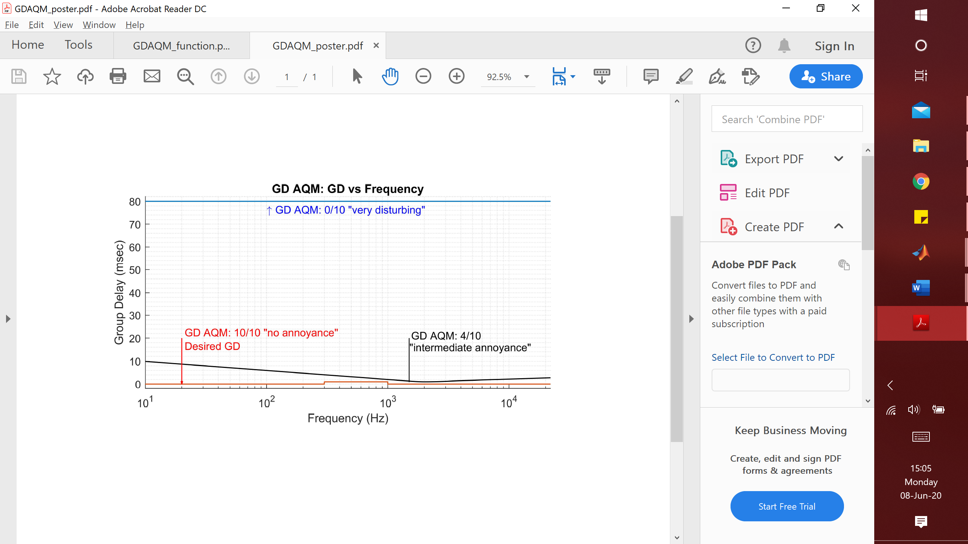

Figure

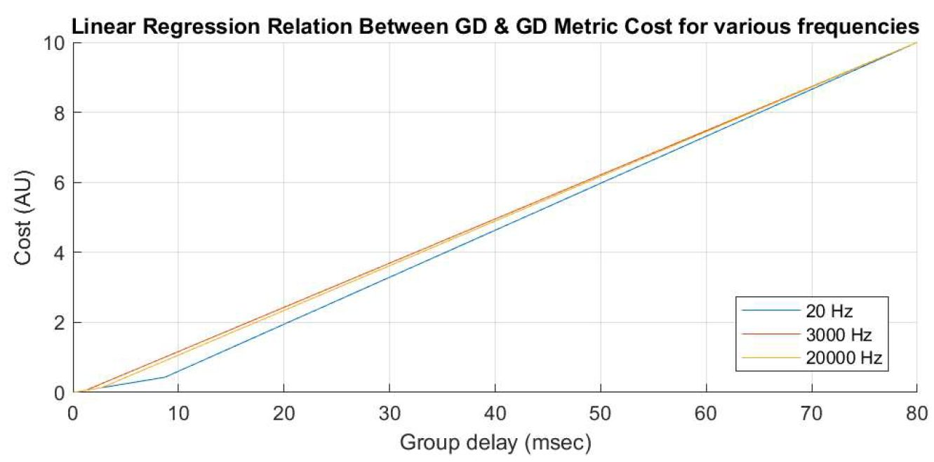

Figure

[1] Quentin Summerfield, Vicki Bruce, Alan Cowey, Andrew W. Ellis and D. I. Perrett 1997Lipreading and audio-visual speech perceptionPhil. Trans. R. Soc. Lond. B33571–78

http://doi.org/10.1098/rstb.1992.0009

[2] Liski, Mäkivirta, and Professor Välimäki, 2018, Audibility of loudspeaker group-delay characteristics https://research.aalto.fi/en/publications/audibility-of-loudspeaker-groupdelay-characteristics(d896fdd8-780a-4ada-b9e5-41455829fd38).html

[3] Blauert & Law, 1978, Group delay distortions in electroacoustical systems http://shabad.ru/forumaml/attachment.php?attachmentid=1167&d=1258235560

[4] Goehring, Tobias, Josie L Chapman, Stefan Bleeck, and Jessica J. M Monaghan. "Tolerable Delay for Speech Production and Perception: Effects of Hearing Ability and Experience with Hearing Aids." International Journal of Audiology 57.1 (2018): 61-68. Web.

[5] Stone, Michael A., and Brian C. J. Moore. "Tolerable Hearing Aid Delays. II. Estimation of Limits Imposed During Speech Production." Ear and Hearing 23.4 (2002): 325-38. Web.

Marcella Iswanto, 2020 June 08th